**University of Michigan – Dearborn**

**CIS 150 – Computer Science 1**

**Lab# 2**

Quan Le

[lmmquan@umich.edu](mailto:lmmquan@umich.edu)

January 23, 2024

**Table Content**

Contents

Question 1 3

Test Cases 3

Source Code 3

Screenshots 3

Question 2 5

Test Cases 5

Source Code 5

Screenshots 5

# Question 1

## Test Cases

|  |  |  |  |  |  |
| --- | --- | --- | --- | --- | --- |
| Test # | Valid / Invalid Data | Description of test | Input Value | Actual Output | Test Pass / Fail |
| 1 | Valid | Input 3 pennies, 4 nickels, 5 dimes, 6 quarters, and 1 dollar. Total should be 3.23. | pennies = 3  nickels = 4  dimes = 5  quarters = 6  dollars = 1 | total = 3.23 | Pass |
| 2 | Valid | Input 1 pennies, 2 nickels, 3 dimes, 4 quarters, and 5 dollars. Total should be 6.41 | pennies = 1  nickels = 2  dimes = 3  quarters = 4  dollars = 5 | total = 6.41 | Pass |
| 3 | Valid | Input 5000 pennies, 52 nickels, 10000 dimes, 1000000 quarters, and 10000 dollars. Total should be 261053 | pennies = 5000  nickels = 52  dimes = 10000  quarters = 1000000  dollars = 10000 | total = 261053 | Pass |
| 4 | Valid | Input 0 pennies, 0 nickels, 0 dimes, 0 quarters, and 0 dollars. Total should be 0 | pennies = 0  nickels = 0  dimes = 0  quarters = 0  dollars = 0 | total = 0 | Pass |

## Source Code

The source code for this question has been uploaded to Canvas as lab2q1.cpp.

## Screenshots

Test Case 1:

Test Case 2:

Test Case 3:

Test Case 4:

## Question 2

## Test Cases

|  |  |  |  |  |  |
| --- | --- | --- | --- | --- | --- |
| Test # | Valid / Invalid Data | Description of test | Input Value | Actual Output | Test Pass / Fail |
| 1 | Valid | The input for x is 5 and the input for y is 3. The output should be 8. | x = 5  y = 3 | z = 8 | Pass |
| 2 | Valid | The input for x is 0 and the input for y is 10000. The output should be 10000. | x = 0  y = 10000 | z = 10000 | Pass |
| 3 | Valid | The input for x is 123456 and the input for y is 987654. The output should be 1111110. | x = 123456  y = 987654 | z = 1111110 | Pass |
| 4 | Valid | The input for x is -10000 and the input for y is 10000. The output should be 0. | x = -10000  y = 10000 | z = 0 | Pass |

## Source Code

The source code for this question has been uploaded to Canvas as lab2q2.cpp.

## Screenshots

Test Case 1:

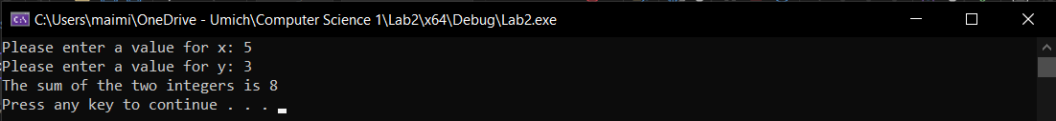

Test Case 2:

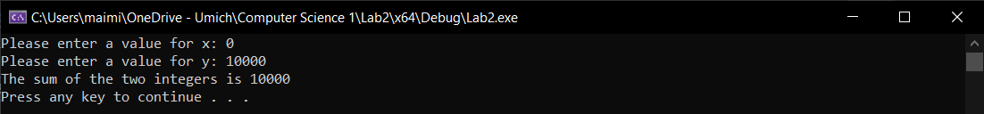

Test Case 3:

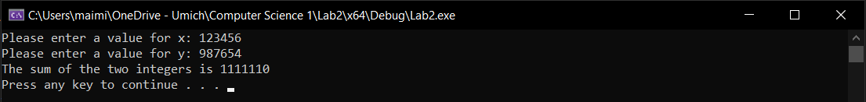

Test Case 4:

